City of Tetonia
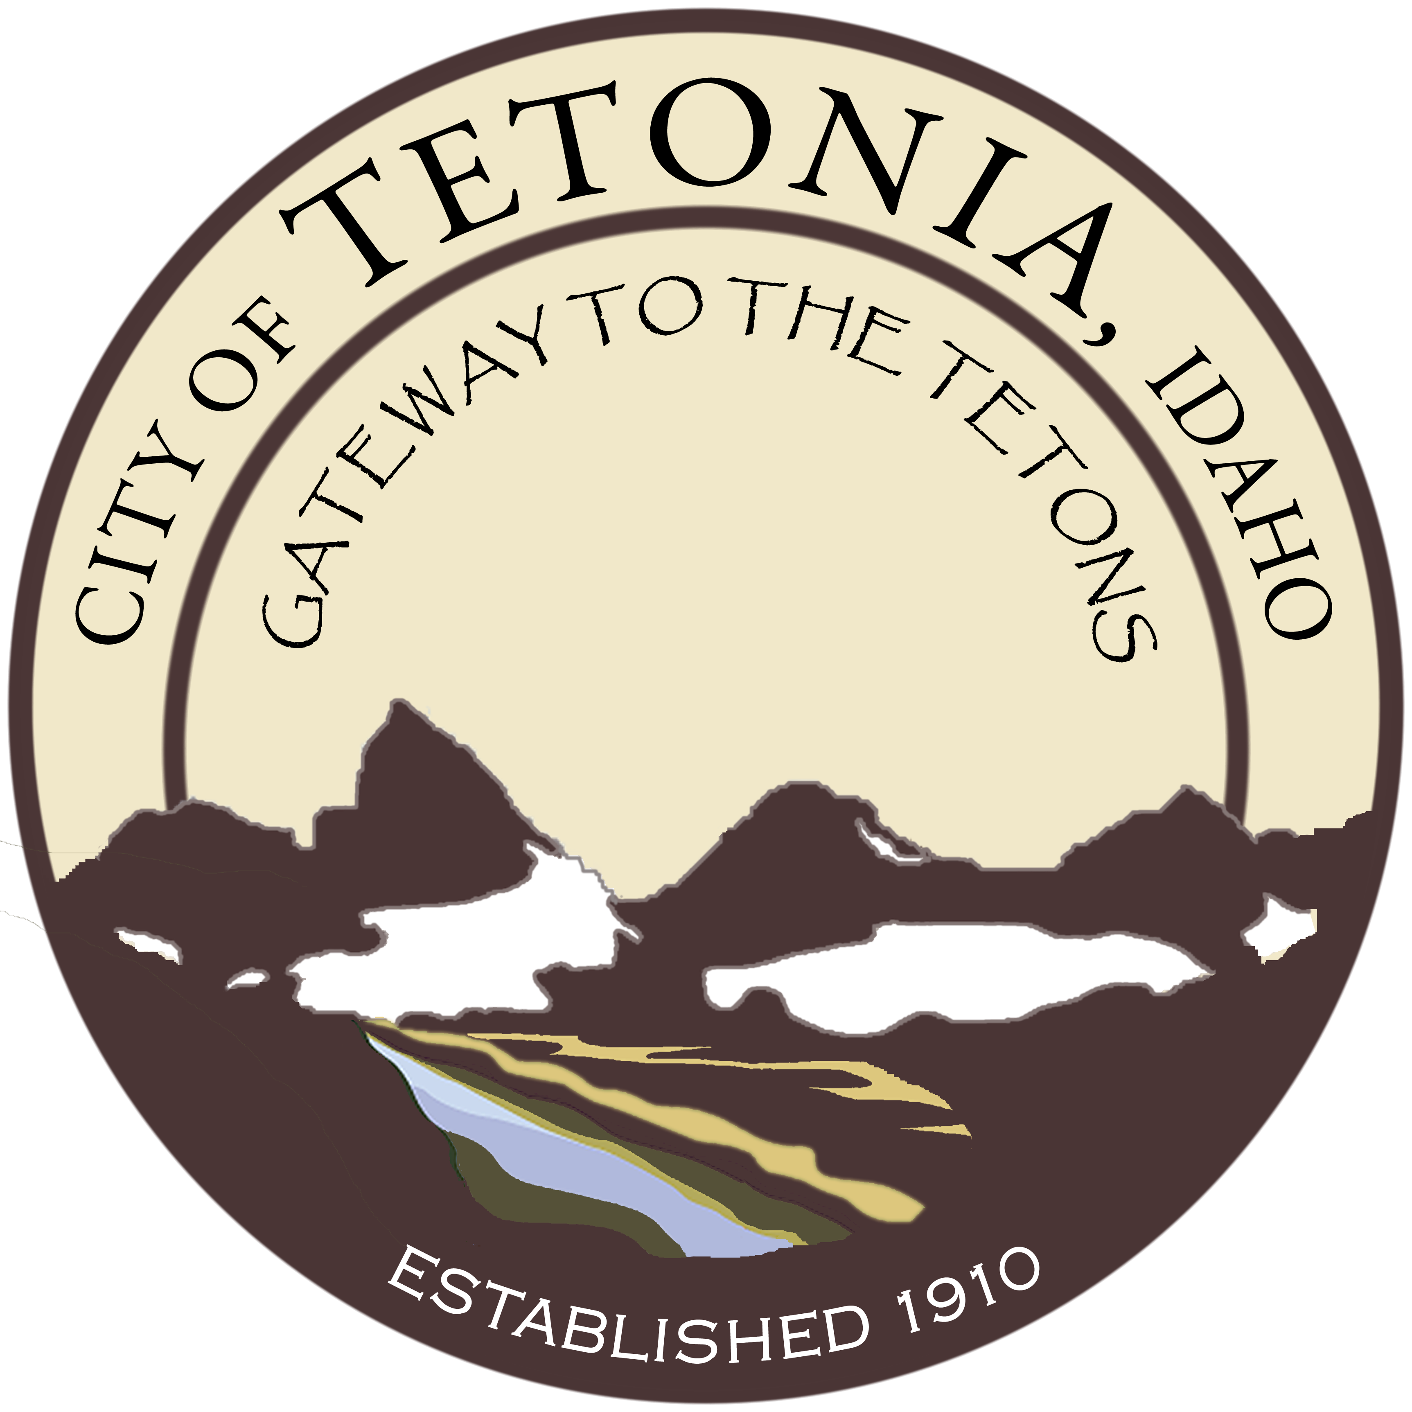
City Council
PUBLIC HEARING
PROPOSED BUDGET FY 2018
City Hall-3192 Perry Ave
August 14, 2017
6:30 pm

Agenda
Open Meeting
- Call to order by Council President/Pledge of Allegiance
- Roll call by Clerk
- Amended Agenda if needed (stating the “good Faith” reason why in Accordance with Idaho Code 67-2343)

General Business
Individual members of the public who wish to address the City Council will be given 3 minutes to voice their opinions/views concerning the proposed City of Tetonia Budget for FY 2018. Individual members of the public who wish to address the City Council will be given 3 minutes to voice their.

Regular Monthly Meeting of the Tetonia City Council will follow.

