City of Tetonia
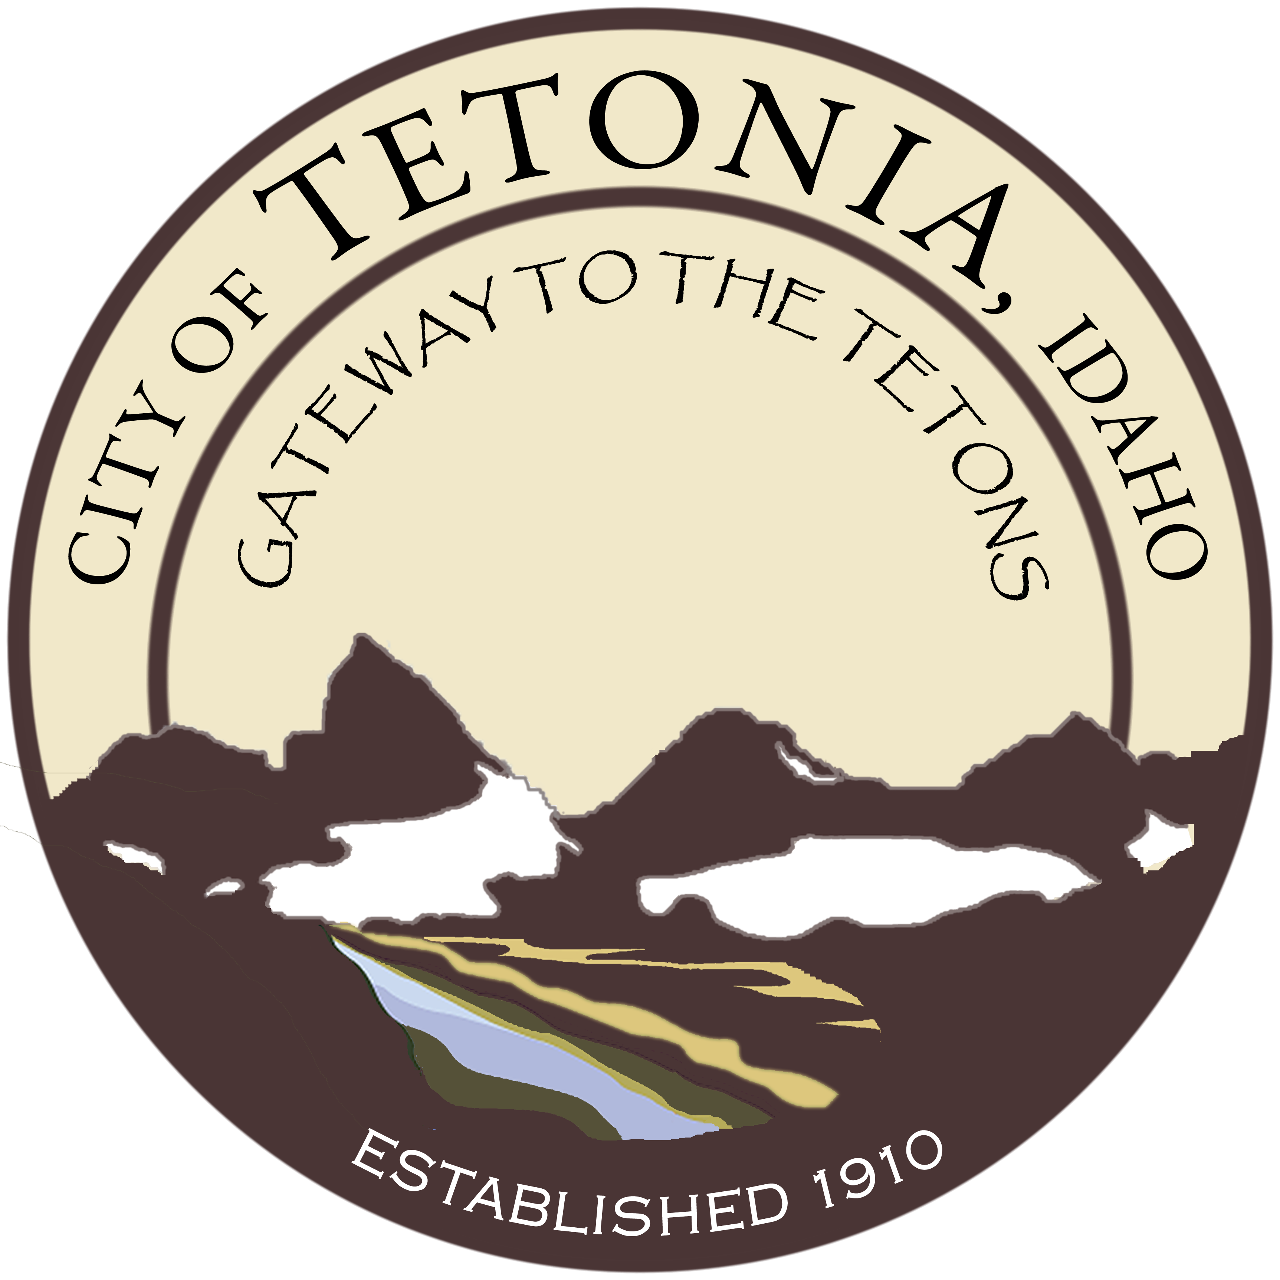
Tetonia City Council Meeting
City Hall-3192 Perry Ave
September 11, 2017
7:00 pm

Agenda
Open Meeting
Open Meeting
- Call to order by Council President/Pledge of Allegiance
- Roll call by Clerk
- Amended Agenda if needed (stating the “good Faith” reason why in Accordance with Idaho Code 67-2343)

General Business

- Update on Water Project - Lana Duke, USDA; Kevin Harris, Forsgren Engineers
- Approval of people chosen for the housing authority advisory committee
- Consideration of Velda Hill utility bill
- Update on Budget to Actual
- Annual Appropriation Ordinance FY 2018 Budget - -passage by roll call vote
- Selection of Auditor for the City
- Review of ICRMP insurance policy – renewal date October 1, 201
- Begin review of Comprehensive Plan

Public Works
Planning and Zoning
Consent Agenda

- Approval of Minutes
- Claims and Revenue
- Aging Report/Delinquencies

