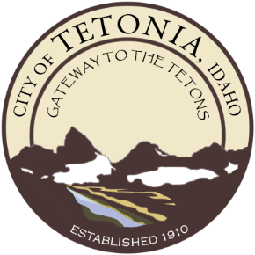

PUBLIC HEARING NOTICE
CITY OF TETONIA, IDAHO
Planning and Zoning Commission
Pursuant to established procedure, NOTICE IS HEREBY GIVEN that the Tetonia Planning and Zoning Commission will hold a public hearing at the Tetonia City Hall, 3192 Perry Ave, Tetonia, Idaho on Monday, October 4, 2021 at 7:00 PM. The meeting will also be accessible via phone or online.
The Purpose of the hearing is to consider a CONDITIONAL USE PERMIT (CUP) to allow for a roadside stand in the CD Downtown zone. The subject property is the City’s pocket park located at the southwest side of the intersection of Leigh Ave and Hwy 33. Stephanie Burnside is requesting to operate a food truck on a yearly basis at this location.
As required by Idaho Code 67-6525, at the hearing, the Tetonia Planning & Zoning Commission will consider how the CUP meets the criteria of the Land Development Code Title 9 CH 6 and make a recommendation. Information pertinent to this application is available for review upon request at the Tetonia City Hall or via email.
Written comments must be received by 5 p.m. Wednesday, Sept 29th at Tetonia City Hall P.O. Box 57, Tetonia, Idaho 83452. You may also email a response to planner83452@gmail.com. Verbal and written comments will be heard during the public hearing. Please contact City Hall during business hours to access the meeting online or call-in.

