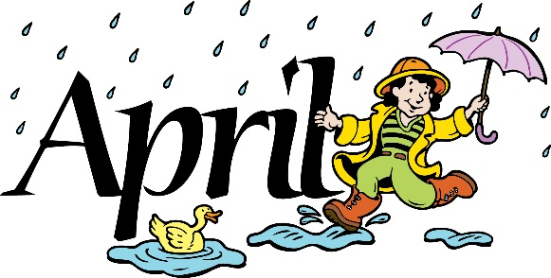

Dear Citizens,
First of all, I would like to thank all the people who have helped with our activities and challenges through the winter. Brent and Gary Robson organized the snow plane enthusiasts to provide a great Snow Plane Rally even though they barely had enough snow to get the planes in the park. We appreciate the efforts and contributions of everyone involved and everyone who attended the event.
I’d also like to thank all those people who have been helpful, considerate and supportive while Mitch Beard, our public works director, has recovered from a heart attack and open-heart surgery. He is back at work but still needs to take it easy. If you have questions or needs call the office (208) 456-2249, and we will try to take care of whatever you need.
I would also like to thank Stacey Durtschi and her team who provided the local children with another successful Easter Egg Hunt. All the children received prizes and had a good time gathering the eggs.
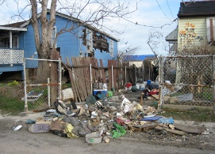
Now that the snow is disappearing quickly it is time to look ahead to spring activities and spring work. As a result of the survey we sent out last fall and the comments we have received from citizens it looks like one of the big jobs for spring is city clean-up. Many people have listed that as the highest priority for the city in the coming year. Everyone loves a small town, no one loves a run-down small town. We are going to make that our first priority this spring. We have noticed how many people in town have already been working to improve their properties and we truly appreciate their efforts. Tetonia will be participating with the rest of the County to make May 14-19 Clean Up Week and Arbor Day for the community. During that time the city will have the dump truck available to take trash to the transfer station without a charge. Please check with the city office to find out how and when to take advantage of that opportunity. On May 19th the County Emergency Management Office will have a container available to take unused tires.
We have included our city nuisance ordinances concerning trash and the duties of property maintenance. Please check to see that you are not in violation. After the 19th of May we will begin issuing violation notices. If you feel you cannot for any reason meet this deadline you need to notify the city office to make an appointment to meet with the City Council to discuss a reasonable solution. Our goal is not to penalize citizens but to create a better community for our citizens, businesses, and visitors. If you need extra help in cleaning your yard, or if you are willing to volunteer to help others, please let us know in the city office and we will try to provide for your needs.
The water project that began last fall will be starting up again this week. It will probably last throughout the summer. This will create some disruptions on different streets at different times during the summer. This is a necessary part of city improvement and we hope you will be patient and cooperative with the workers. Everyone should be rewarded with a better water system, with fewer frozen pipes and a more even water flow.

Thank you,
Gloria Hoopes

